Go Missions to Mexico
Christ-Centered Ministry
Fees
Per Person / 7 Day Trip
Adults/Youth $225
Children (Ages 6-12) $200
Pre-School (Ages 0-5) Free
Fees include:
Lodging, building materials & tools for work projects, media & ministry equip., coordination of all ministries and our on-site assistance.
Short Term
Mission Trip
Opportunities
to Mexico!
We are Long Term Missionaries
who use Short Term Mission
Teams in fulfilling the Great
Commission!

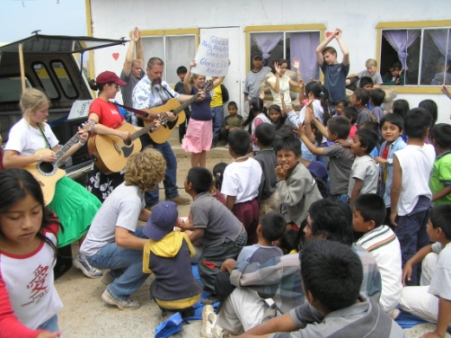

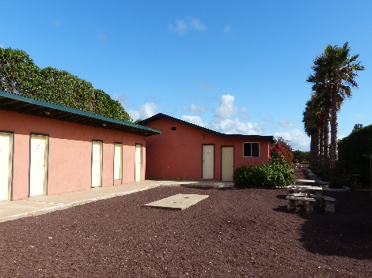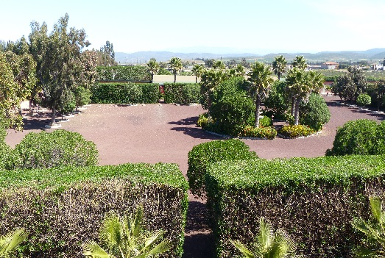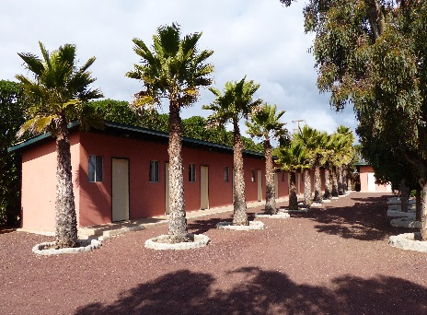

Large, accommodating Mission Base located 4 hours south of San Diego in Baja, Mexico.

What will you do on your short-term mission trip to Mexico?
Your group will minister at a specially chosen church (alongside Mexicans) the week you're in Mexico. Through this church, you'll do your ministries & outreaches. By strengthening and working through the local church, your fruit will remain long after you're gone. This philosophy ensures maximum fruit and impact.

In the mornings we offer two ministry options: (1) You can be involved in work projects. This is a great time to serve by improving needy church facilities. By helping churches with their buildings, and by helping new churches we're planting, you're participating in true and lasting results for the people of Mexico. (2) We offer the rare treat of participating in an evangelism/visitation/prayer ministry where you'll visit homes of Mexicans to experience their culture up close and see how they live. You’ll also pray, minister and share the love of Christ with them. You’ll have plenty of time to be involved in both ministries if you’d like.
For lunch, you'll have the option of eating at the church you're serving with. This is a highlight as the meal is
prepared by the ladies from the church and is really tasty and authentic. You'll not want to miss this special treat.
In the afternoons we also offer two ministry options: (1) VBS Outreach. This is a “hands-on” time of ministry with Mexican children ranging in ages from 3-12. You'll play games, sing songs, do a puppet show, participate in a Bible Story (via video we provide), and do crafts & snacks. It's a favorite for all. We provide the VBS program, so preparation is easy. (2) For or those who’d prefer, they can continue working on the work projects begun in the morning. We also offer the option of ministering to the youth of Mexico if your team would like.
Several evenings during the week you'll participate in Church Ministry Outreaches. You'll sing, share testimonies, do a puppet show, show an evangelistic movie (provided by us) and more. Be prepared to be touched by the Mexican people you'll serve.
We also have close-by beaches that are sandy and little used. You'll have plenty of free time for this rich treasure so plan on taking advantage of this great resource.

In addition to ministry, you'll have the opportunity to see and experience another culture up close. You'll be immersed in the culture, language and people of Mexico. You'll also have plenty of free time, along with a free day on Friday, to shop, eat out, enjoy the beaches, have your own group activities and experience the local culture. Please consider serving with us in Mexico as you’re greatly needed!
www.GoMissionsToMexico.com

